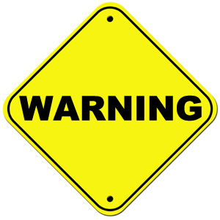 | 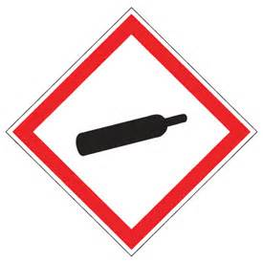
CONTAINS REFRIGERATED GAS: MAY CAUSE CRYOGENIC BURNS OR INJURY MAY DISPLACE OXYGEN AND CAUSE RAPID SUFFOCATION

Handling Procedures
- Transfer liquids slowly to prevent splashing
- Use only containers approved for LN₂
- Do NOT restrict pressure relief device

PPE Requirements
- Cryogenic Gloves
- Goggles and Face Shield
- Lab Coat
- Long Pants
- Closed-toe Shoes

DO NOT ENTER ROOM/EVACUATE AREA
IF OXYGEN SENSOR IS ALARMING
Contact Public Safety IMMEDIATELY at x13

Researcher(s) ___________________________ Phone (daytime) ______________ Phone (after hours) _____________
Information (name)

__________________________ Phone (daytime) ______________ Phone (after hours) _____________
(name)

