This sign is posted at the entrance to the laboratory when infectious materials are present.

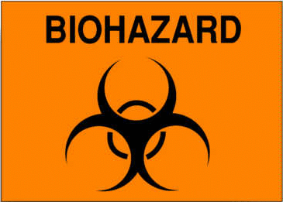**If you need access to this lab**, see the bottom of the GHS sign (blue/white CAUTION) for who to contact.

**Lab**

PI or lab name(s)

**Biohazardous Agents:**

|  |  |
| --- | --- |
| Present? | Agent name |
|  |  |
|  |  |
|  |  |
|  |  |
|  |  |

# Biosafety Level 2+

BSL2+ means additional work practices are used when working in a BSL2 lab. When working, avoid sharps and:

* Verify lab has inward directional airflow.
* Work in a biological safety cabinet or in other aerosol containment (why splash protection for the face is not required). Place pipette tips in 10% bleach or other disinfectant listed in the IBC LAB form.
* Use centrifuge safety cups or sealed biological safety rotors

**Entry Procedures:**

* Arrange entry with lab personnel. Use additional caution if you are immune-suppressed.
* If you can see a person working at a biological safety cabinet in this room, knock for admittance.
* Visitors - wear the same Personal Protective Equipment (PPE) that lab personnel are wearing.
* Inside - do not eat, drink, apply face products, handle contact lenses or otherwise touch your mouth/eyes.

**Required PPE when working with infectious materials** (from the IBC LAB form)

|  |  |  |  |
| --- | --- | --- | --- |
|  | **PPE** | **Tasks** | **Types** |
|  | Gloves | Worn when opening containers of infectious agents, performing work with open containers or touching potentially contaminated surfaces | Nitrile  Latex  Double  Dispose outer in BSC |
|  | Lab coat | Worn to protect street clothes when working at the bench or in a biological safety cabinet. | Closed front disposable  Sleeve covers |
|  | Additional |  |  |

**Occupational Health for working with infectious materials** (from the IBC LAB form)

|  |  |
| --- | --- |
|  | **Hepatitis B Vaccine:** Offered if have a ‘reasonably anticipated’ risk of exposure to human blood, tissue or cells. |
|  | **Seasonal Influenza Vaccine:** Recommended for all individuals working with influenza or inoculated animals. |
|  | **Other:** |

**Exit Procedures:** If worked with infectious materials - remove PPE and leave it in the lab. Wash your hands.