University of Rochester
Research and Clinical Laboratory Waste Disposal

Use this generalized table to determine the appropriate disposal of a material from a laboratory. If additional information or clarification is needed, please contact:

EH&S Environmental Compliance at 275-2056 | EH&S Radiation Safety at 275-3781
Environmental Health and Safety (EH&S) main office at 275-3241, or your EH&S Laboratory Safety Unit inspector
Medical Center Environmental Services (formerly Housekeeping, not part of EH&S) at 275-3666

Table of Contents:
Mixed Waste Radionuclides
Sharps, Glass, Pipettes Contaminated Sharps
Regulated Medical Waste and Biologicals
Chemicals Pharmaceuticals
Standard Trash and Recycling

Mixed Waste
Avoid generating mixed waste whenever possible. If your work requires the disposal of mixed waste, follow the hierarchy of waste:

Radiological
↓
Biological
↓
Chemotherapeutic
↓
Chemical
Container color must match the most hazardous waste included in the mixture:
- Red for biologicals and medical waste
- Yellow for chemotherapy waste
- Green, white, or clear for chemical waste


- Any item contaminated with radiological materials must be disposed of through EH&S Radiation Safety
- Mixed radiological and biological liquid waste:
  - First disinfect the biological
    - Clinical areas: hospital approved disinfectant
    - Research areas: disinfectants approved in IBC Lab/L-form
  - After proper contact time, treat as radioactive liquid waste. If the biological cannot be disinfected, contact Radiation Safety.
  - Mixed biological and chemical waste – avoid generating this waste if possible
- First disinfect the biological
  - Clinical areas: hospital approved disinfectant
  - Research areas: disinfectants approved in IBC Lab/L-form
- After proper contact time, treat as chemical waste.
  - Dispose of through Chematix as “Chemical Mixture by Percentage”
- If your work requires the generation of mixed biological and chemical waste, contact
EH&S Environmental Compliance to review how this waste can be minimized.
Do NOT place the following in red bins:
- Chemicals – must be disposed of through CHEMATIX.
- Empty drug vials – may be disposed of as standard trash.
- Any volatile chemicals such as TriZol – vapors will be released every time the waste container is opened.
- Electronics waste, unless biologically contaminated.

Radionuclides
Pickup requests may be made through the Radiation Safety Service Request Portal

Non-sharps solid waste:
Please note: If you are located in the Medical Center, MRBX, or KMRB, it is required that you take any solid radioactive waste to the waste room located at B-5730. Off-site waste in all forms will be picked up by Radiation Safety via portal service request.
- Place in cardboard box lined with plastic bag supplied by EH&S Radiation Safety.

Segregate long-lived (half-life >90 days) and short-lived (<90 days) radionuclides into separate containers.
- When full, deliver to room B-5706.
Sharps:
- Place in sharps container purchased by the lab and labeled with radioactive symbol.
- When pre-printed fill line is reached (roughly ¾ full), close lid.
- Submit a pickup request through the EH&S Radiation Safety portal.

Liquid Scintillation Vials:
- Place full scintillation vials into blue fiber drums provided by EH&S Radiation Safety.

Liquid scintillation vials do NOT need to be emptied into liquids bottle.
- When full, deliver to room B-5730.
Liquids:
- Pour liquid waste into plastic 5-gallon bottles supplied by EH&S Radiation Safety.

All liquid waste containers must be stored within a secondary container capable of holding 110% the volume of the waste.
- Segregate aqueous and organic liquids into separate bottles.
  - Do NOT over-fill bottle. Liquids CANNOT extend into “neck” of bottle.
- Submit a pickup request through the EH&S Radiation Safety portal when

bottle/drum is full.
EH&S Radiation Safety Service Request Portal:
- All radioactive materials requests must be accompanied by a portal form. An additional area has been added to the portal form for these services.
- Access requires using University networks or a VPN. Visit the portal at Radiation Safety Unit - Intranet (rochester.edu)
- Please include all financial information on all portal sheet requests that are emailed to Radiation Safety Support. The portal request will not be accepted without financial information.

New York State Department of Health license renewal invoices must be forwarded to Patty Pschierer, Radiation Safety, Box HPH, including ALL forms and the envelope. Do not pay the invoice. Radiation Safety handles the payment of these renewals.

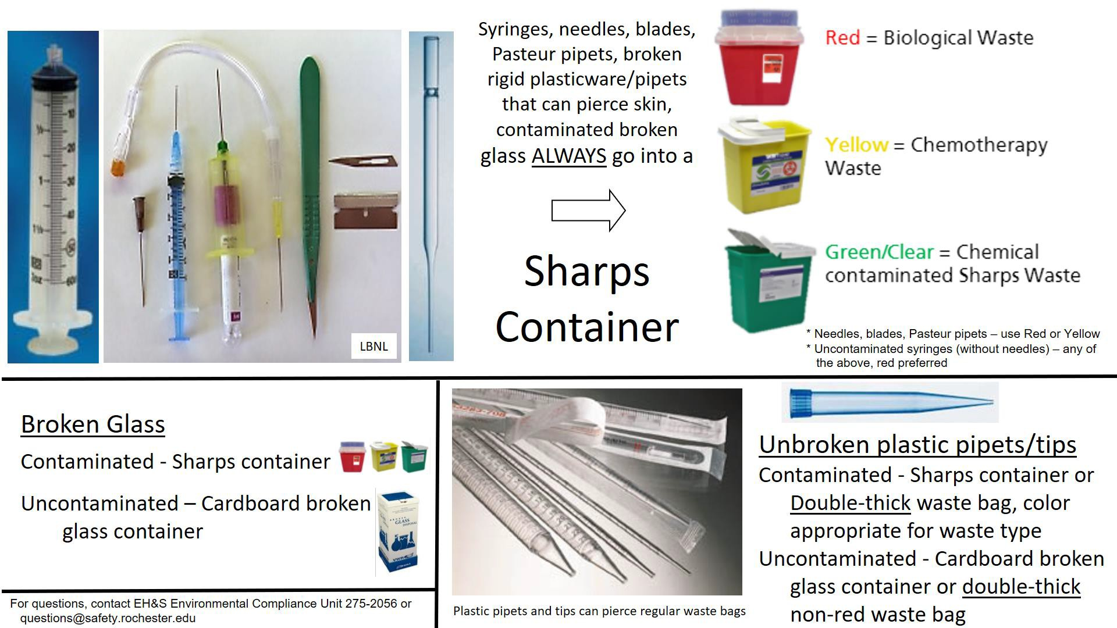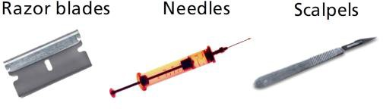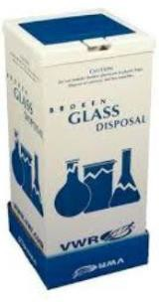Sharps, Glass, Pipettes
NEVER PUT SHARPS INTO THE REGULAR TRASH!!

A sharp is defined as any needle or syringe, used or unused. Or any item that can cut, puncture, or scrape human skin and is contaminated with an infectious agent.

Glass (broken or intact)
- Contaminated – disposed of as a sharp
  - Examples: reagent bottles, blood tubes, microscope slides, capillary tubes, pipettes, beakers, flasks, graduated cylinders, Pastuer pipettes, etc.
- Uncontaminated
  - Cardboard ‘broken glass containers’ – purchased by the lab, must be taped closed
and disposed of as regular trash.
  - Generic cardboard box – must be taped closed and disposed of as regular trash.

Plastic pipettes/tips - Unbroken pipets are not considered sharps, but can pierce regular trash bags. To prevent this:
- Contaminated - Sharps container provided and closed by lab when pre-printed fill line (approximately ¾ full) is reached
  - If unable to fit in an appropriate sharps container: Red bag sufficiently thick (4 mm) to prevent puncture, provided by lab – tied by lab personnel using either a single-knot or gooseneck (see pictures on the Regulated Medical Waste Page)
- Uncontaminated
  - Cardboard “broken glass containers” – purchased by the lab, must be taped closed and disposed of as regular trash.
  - Generic cardboard box – must be taped closed and disposed of as regular trash.

If you work in a research lab, see your “Lab-Specific Sharps Safety Plan for nonhazardous or chemical-contaminated
sharps” and/or your IBC L/Lab form. The Sharps Safety Template can be found here.

Contaminated Sharps
Contaminant | Items for Disposal | Proper Disposal Method
Radionuclides | Sharps and Glass | - Place into sharps container purchased by the lab and labeled with radioactive symbol.  - When pre-printed fill line is reached (roughly ¾ full), lab personnel close lid.  - Submit pickup request through the EH&S Radiation Safety portal.
Biologicals | Intact Blood Tubes | - Place paper towels or other absorbent, enough to prevent dripping if tubes were to break, in the bottom of into red bags labeled with the biohazard symbol.  - Dispose of tubes in bag.
Chemotherapy (For the full list, please review  the Environmental Compliance  Learner’s Guide.) | Sharps and Glass  EMPTY Containers | - Place in Yellow sharps container labeled with the biohazard label and the words "Chemo or chemotherapeutic waste" and "Incineration only," purchased by lab personnel.  - When pre-printed fill line is reached (roughly ¾ full), lab personnel close lid.  - Place in yellow toter or Environmental Services will pick up for off-site processing.
Creutzfeldt-Jakob Disease (CJD) Waste | Sharps waste from patients known or suspected to have CJD | - Place in Yellow chemotherapy sharps container labeled with the biohazard label and CJD label placed over Chemo label  - When pre-printed fill line is reached (roughly ¾ full), lab personnel close lid and dispose of as with Chemo waste above
Chemical Hazardous Waste  Discarded commercial products:  - EPA P list (acutely toxic) | Sharps and Glass  EMPTY reagent bottles | Sharps and glass - place in green or clear sharps containers purchased by lab personnel (deface biohazard symbol if pre- printed). Dispose of through Chematix as chemical “debris”.  Empty containers  1. Dispose of through Chematix as chemical “debris”.
Chemical Hazardous Waste  Discarded commercial products:  - EPA U list (toxic)  - D list Characteristic Waste: ignitable, corrosive, toxic, reactive, acutely hazardous, or environmental hazard  - Contains polychlorinated biphenyls (PCBs)  - F, K – less relevant for UR labs | Sharps and Glass  EMPTY reagent  bottles | Sharps, broken glass, intact glassware - Place in green or clear sharps containers purchased by lab personnel. Dispose of through Chematix as chemical “debris”.  Empty containers (including intact glass)  - Triple rinse and discard rinsate down the drain.  - Completely deface or remove chemical label.  - Container can then be:  - Reused as chemical waste bottle  - Recycled  - Discarded in regular trash  - If glass, discarded in cardboard “broken glass box” lined with clear bag. Lab personnel close liner and box and call Environmental Services for pick up.
Pharmaceuticals | Sharps and Glass  EMPTY Containers | - Within SMH, use disposal code printed on Pharm Waste container to dispose of in black Rx bins (BKC coded items) or blue RX bins (un-coded items).  - At off-site clinical locations, dispose of unused or partially used Pharm waste in black Rx bin.





Regulated Medical Waste & Biologicals
Red Biohazard bins and bags must be purchased and replaced by labs.

Non-sharps solid waste (petri dishes, tissue culture flasks, bench paper, gloves, kim wipes, paper
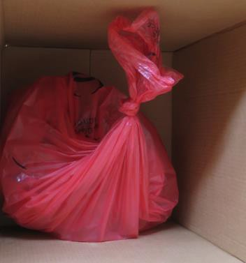towels, bandages, etc.)
ot
single-kn
- Line a reusable red biohazard bin or cardboard box with a red bag
- Place materials into red bags labeled with the biohazard symbol
  - NOTE: waste must not reach a level where it lifts the waste bin lid
  - If waste contains liquid, add paper towels or other absorbent to bottom of bag
- Tie bag closed using either a single-knot or gooseneck, as demonstrated below
- MC - Place closed bag into red toter for shipment to Stericycle
Gooseneck: gather top, twist end, fold twisted end over, seal tightly with either tape or zip-tie.

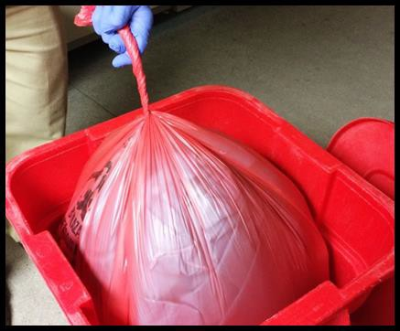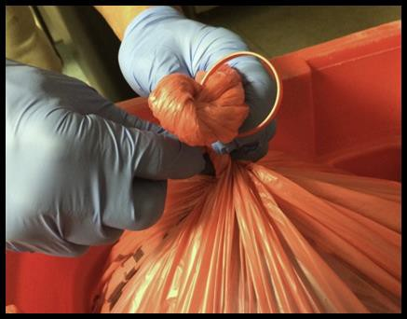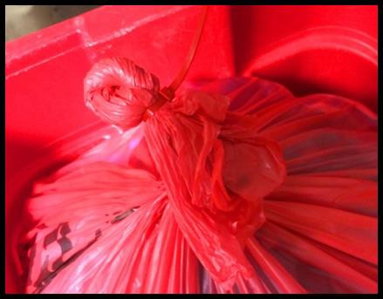

NOTE: Items contaminated with dried blood are not considered Regulated Medical Waste and can be disposed of in the normal trash.

Liquids:
Photo reference: DOT – Packaging and Shipping SARS-CoV-2 Waste

- Research Labs – see lab-specific UR Institutional Biosafety Committee (IBC) L/Lab form
- Clinical labs – follow lab procedure, or add household or germicidal bleach (1 part bleach: 9 parts liquid waste) and allow to stand for at least 30 minutes. Dispose in a dirty sink by pouring down the drain.

Tissues:
- Unfixed Pathology Waste (human tissue, organs, body parts, and body fluids removed during surgery, autopsy, or other medical procedures, and specimens of body fluids and their containers, excluding teeth and contiguous structures of bone and gum)
  - This waste must be disposed of through Pathology
  - Fixed Pathology Waste (human body parts/organs/tissues preserved in formaldehyde)
    - Pour off fixative and dispose of as chemical waste
      - Medical Center ONLY: 10% formalin may be disposed of down the sink with copious amounts of running water
    - Seal human specimen in a leak-proof container
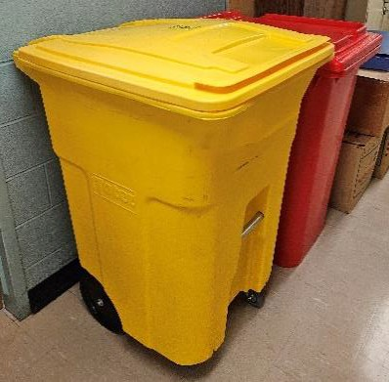
    - Place specimen containers into red bag, tie bag as pictured above, and dispose of in red toter for shipment to Stericycle
Creutzfeldt-Jakob Disease (CJD) Waste: waste from patients known or suspected to have CJD must be incinerated. All chemotherapeutic waste is incinerated so CJD waste may be disposed of in yellow bags labeled with CJD or in special orange bags pre-printed with a CJD label, and placed in yellow toters designated for chemo waste.
Animal carcasses and animal tissue: refer to Vivarium and UCAR requirements

Chemicals
All chemical waste must be disposed of through CHEMATIX
Contact Chematix_support@safety.Rochester.edu to gain access to the system.

Liquid Laboratory Chemicals: DO NOT drain dispose!  - A Hazardous Waste Card must be created in CHEMATIX  using either:  - Pure Chemicals in Individual Containers  - Chemical Mixture by Percentage  - Print Waste Card, cut to size, and tape to container in a way that keeps the waste barcode uncovered and flat  - Create Waste Pickup Worksheet in CHEMATIX  - Submit for pickup in CHEMATIX and place in an area accessible to the Environmental Compliance team | Laboratory Chemical Solids: (dried  chemicals, gloves, paper towels, etc.)  - A Hazardous Waste Card must be created in CHEMATIX using Chemical Mixture by Weight  - Enter each chemical contaminant on a separate line  - Enter the solids as “Debris”  - Follow steps 2-4 as with Liquid Laboratory Chemicals
If disposing of a large amount of chemicals from a lab cleanout or move, contact EH&S Environmental Compliance
for guidance prior to entering the materials into CHEMATIX.

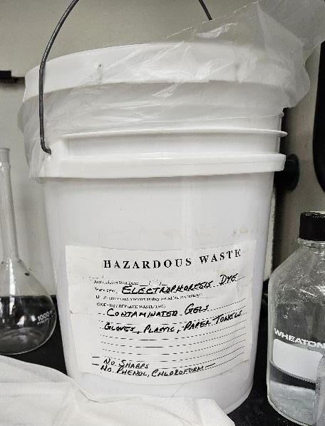
Ethidium Bromide Waste: (gels, solid debris, pipette tips, etc.)
- Discard materials in a sealable bucket supplied by EH&S Environmental Compliance Unit
  - The bucket must be labeled “ethidium bromide waste”
- A Hazardous Waste Card must be created in CHEMATIX using Chemical Mixture by Weight
  - Enter the waste as “Ethidium Bromide Contaminated Gels and Debris”
- Follow steps 2-4 as with Liquid Laboratory Chemicals
- The EH&S Environmental Compliance Unit will replace the used bucket with an empty one.

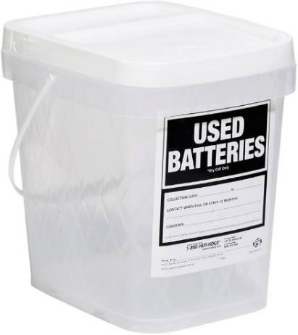
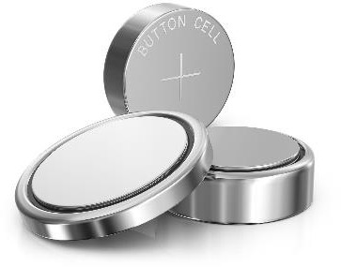
Lead acid batteries, nickel cadmium (rechargeable batteries), mercury/silver (button batteries), lithium batteries:
- Collect in a container labeled “USED BATTERIES”
- Create Hazardous Waste Card in CHEMATIX using Chemical Mixture by Weight and enter each type of battery as a separate line
- Follow steps 2-4 as with Liquid Laboratory Chemicals
These batteries can also be taken to one of the battery collection locations in the Medical Center.

NOTE: Maintain Hazardous Waste containers closed at all times

Pharmaceuticals
DO NOT place empty items or items containing blood or bodily fluids in Rx Waste

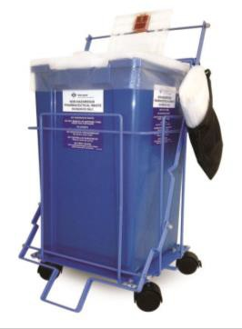
Pharmaceutical agents are regulated materials. For additional guidance, see https://www.safety.rochester.edu/envcompliance/pdf/HazardousMaterialsManagement.pdf

Blue Rx Waste Toter | Leftover/Unused Pharmaceuticals without a message or code:  - Partial IVs  - Unused pills and capsules  - Partial vials  - Topical ointments (capped)  Materials that could potentially leak must be sealed in a ziplock bag
Black Rx Sharps Bin  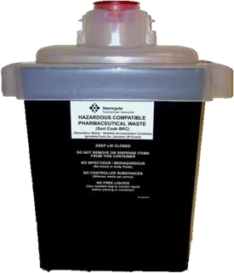 | Leftover/Unused Pharmaceuticals contained in a sharp:  - Syringes  - Ampoules  DO NOT empty liquids from sharps into bin DO NOT dispose of empty sharps
Black Rx Waste Toter | Leftover/Unused Pharmaceuticals marked or coded BKC or PBKC:  - Partial IVs  - Unused pills and capsules  - Partial vials  - Topical ointments (capped)  DO NOT include anything coded SP, SPC, SPO, SPLP or not coded at all  Photo reference: Stericycle – Pharmaceutical Waste Compliance Program
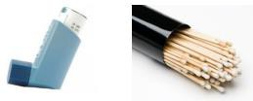
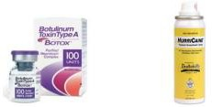
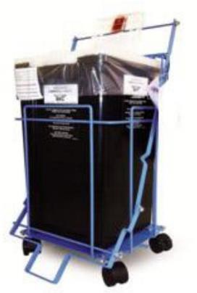
Some items cannot go in pharmaceutical waste containers due to DOT regulations. These items will be marked or coded SP, SPC, SPO, or SPLP. Examples include inhalers/aerosols that use propellant, silver nitrate sticks, containers with leftover Botox® or collodion.
These items must be sealed in a Purple Ziplock Bag and sent to the Pharmacy.

Standard Trash & Recycling
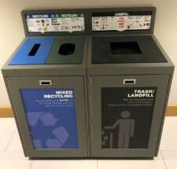
Standard recyclable items can be disposed of in recycling bins located all over campus.

Visit the UR Sustainability webpage for guidance on locations and more specific recycling programs.
Always follow Monroe County guidance on what is recyclable.

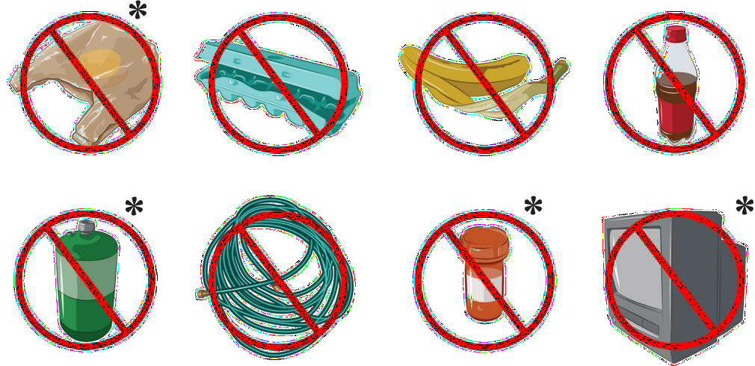
PLEASE break down all cardboard boxes before recycling.
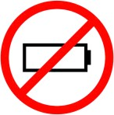
These materials should never be placed in standard recycling:

Alkaline batteries should be disposed of in regular trash. All other batteries must be disposed of as Hazardous Waste.
Photo reference: Monroe County – Residential Recycling

Electronic equipment must be decontaminated and recycled through the IT Equipment Recovery Program. Equipment can be dropped of at MC G.7220B or a pickup can be scheduled by contacting itequipmentrecovery@rochester.edu.
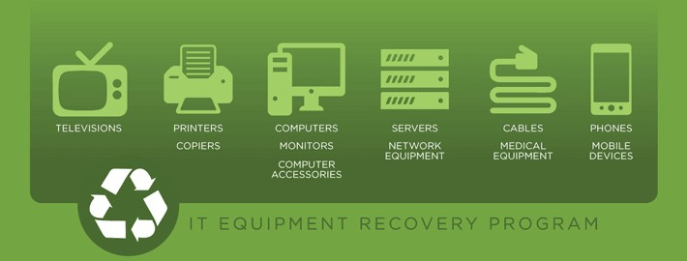

Ink jet and toner cartridges can be recycled through University Mail Services. Place in original or replacement packaging and use inter-office mail to PO Box 270001.

